BRAF (G469E)
Catalog Number: CR-M26196
Gene Symbol: BRAF, BRAF1, RAFB1
Description: Anti-BRAF (G469E) Mouse Monoclonal Antibody

Background: BRAF belongs to a family of serine-threonine protein kinases. As a part of a signaling pathway known as the the RAS/MAPK pathway, it plays an important part in many cellular processes. The processes include cell proliferation, differentiation and transcriptional regulation. Mutations in the BRAF gene cause diseases. Inherited mutations in BRAF cause cardiofaciocutaneous syndrome. Acquired mutations in BRAF have been found in cancers.
Immunogen: A synthetic peptide from the internal region of BRAF which includes the mutation of G469E, human origin.
Tested applications: ELISA, WB, IHC
Recommended dilutions:
ELISA: 1:1000-1:5000
WB: 1:500-1:1000
IHC: 1:50-1:100
Concentration: 1 mg/ml
Host: Mouse
Clonality: Monoclonal
Purity: Purified from ascites
Format: Liquid
Storage buffer:
Preservative: no
Constituents: PBS (without Mg²⁺ and Ca²⁺), pH 7.4, 150 mM NaCl, 50% glycerol
Species Reactivity: Recognizes G469E mutant, but not wild-type BRAF of vertebrates.
Storage Conditions: Store at -20°C. Avoid freeze / thaw cycles.

Western blot:
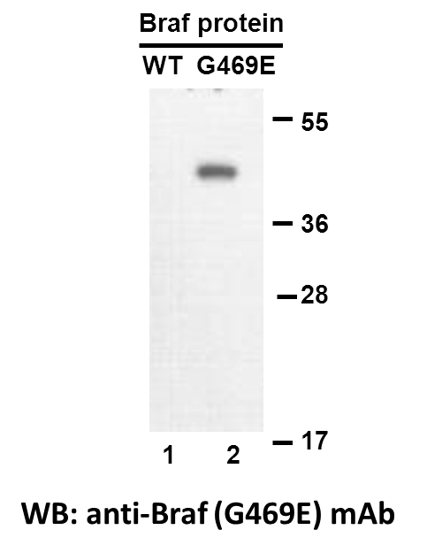
Western blot analysis of recombinant BRAF (G469E) and wildtype proteins. Purified His-tagged BRAF (G469E) protein (lane 2) and corresponding wildtype protein (lane 1) were blotted with anti-BRAF (G469E) monoclonal antibody (Cat. #26196).

Immunofluorescence:
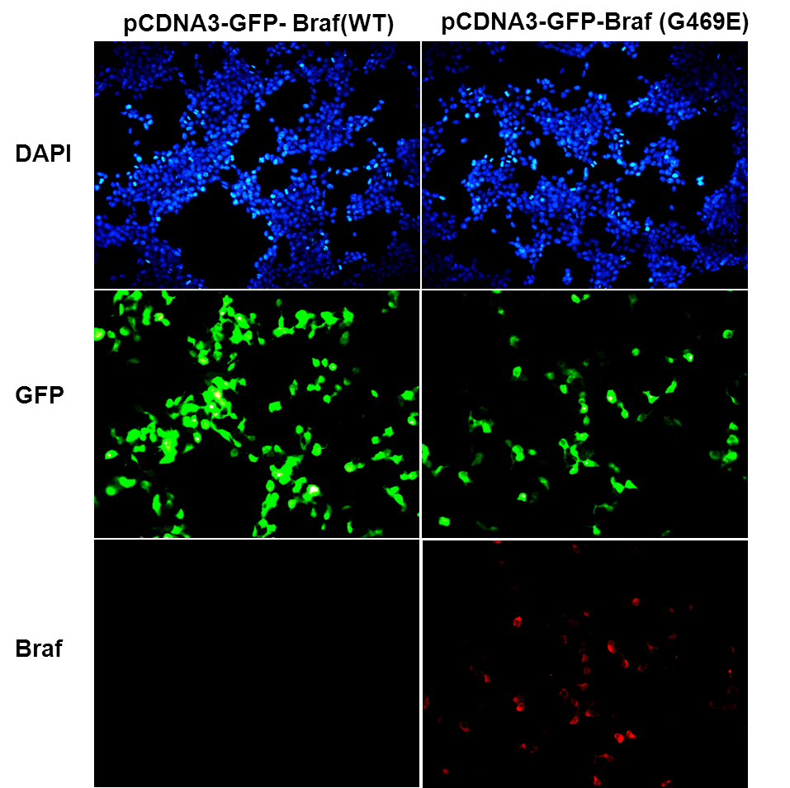
Immunofluorescence of cells expressing BRAF proteins with anti-BRAF (G469E) antibody. HEK293T cells were transfected with pCDNA3-GFP-BRAF (WT) plasmid (left column) or pCDNA3-GFP-BRAF (G469E) plasmid (right column), then fixed and stained with anti-BRAF (G469E) monoclonal antibody (Cat. #26196).

科博瑞（武汉）生物科技有限公司
TEL：027-87615885 15972062685
- mail：3636901710@qq.com
Web:www.coburybio.com

